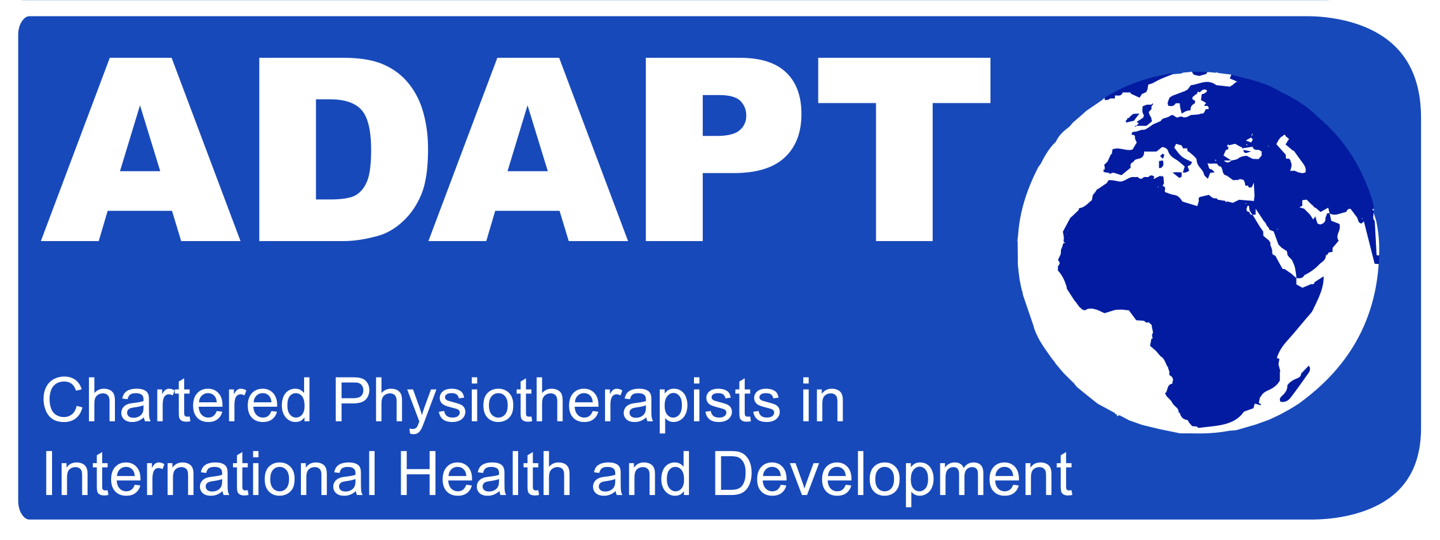
ADAPT CONFERENCE 2016: BEST POSTER COMPETITION

Enter your poster on the theme of multi-disciplinary working now for the chance of winning £30 Amazon gift voucher!

This year at our annual conference ADAPT are running a best poster competition on the theme of MDT working. We welcome poster submissions on this topic, which might include (but is not limited to):

- What does MDT working mean in a low-resourced context?
- Examples of successful MDT working
- Challenges of MDT working
- Considering where disciplinary boundaries lie in low-resourced contexts
- Training rehabilitation professionals in low-resourced settings
- Developing the MDT
- Your experiences of MDT working in low-resourced contexts
- Data on numbers rehabilitation professionals in different countries around the world
- Working with families
- MDT working in diverse settings, for examples children’s homes, rural communities or refugee camps

And any other ideas you can come up with!

We only have space for 10 posters so please email me if you intend to enter at sarahpeck2013@gmail.com to reserve your space. Then bring your printed poster (A2 or A3 size, portrait orientation) with you on the day (either Friday 18th or Saturday 19th November). Three members of the ADAPT committee will judge the entrants and the prize will be awarded at the close of the conference on Saturday 19th September.

A few tips on posters:

- Make use of images/graphics
- Make the title short and memorable
- Not too much text
- Use 3 or 4 different colours max
- Put your name and contact details on it somewhere!

